

|  |
| --- |
| Riko Wolhuter ST101144082023/04/13 PDAN8411  Part 1 |
| Contents  1. Table of contents………………………………………………………………………………………………………..2 2. Background…………………………………………………………………………………………………………...…3 3. Linear Regression…………………………..……………………………………………………………………..……3 4. Multiple linear regression……………………..……………………………………………………………………..…4 5. Outlier, Leverage, and Influential Points….……………………………………………………………………..……4 6. Bias/Variance Trade-off….…………………………………………………………………………………...…..……4 7. Overfitting and Underfitting…………………………………………………………………………………………….5 8. Analysis done on data set for linear regression and how its appropriate…………..………...…………………..5 9. Linearity………………………………………………………………………………………………………………….6 10. Independence…………………………………………………………………………………………………………...6 11. Homoscedasticity..…………………………………………………..…………………………………………………6 12. Normality………………………………………………………………………………………………………………...6 13. Sample Size…………………………………………………………………………………………..………………...6 14. Multicollinearity…………………………………………………………………………………………..……………..7 15. Outliers in Statistics…………………………………………………………………………………..………………..7 16. Data analysis performed on the data set……………………………………………………...…………………….8 17. Dataset…………………………………………………………………………………………...……………………..8 18. Analysis……………………………………………………...……………………………………………..…………..8 19. Modeling……………………………………………………...……………………………………………..…………11 20. Evaluating accuracy of Model……………………………...……………………………………………..…………12 21. Recommendations……………………………...………………………………………………………….…………12 22. Process of data analysis……………………………………………………………………………………………..12 23. Data collection………………………………………………………………………………………………………...12 24. Data cleaning and preprocessing. ……………………………………….…………………………………………12 25. Exploratory data analysis. …………………………………………………………………………………………..13 26. Visualization tools and techniques. ………………………………………………..………………………………13 27. Data modeling with machine learning. …………………………………………………….………………………14 28. Data quality assessment. …………………………………………………………………………………………...14 29. Data interpretation. …………………………………………………………………………………………………..15 |

# Background

The process of applying to universities and getting accepted is stressful for students. A dataset has been built to help students in shortlisting universities based on their academic records. This dataset is inspired by the UCLA Graduate Dataset. The analysis aims to understand the factors that contribute to graduate admission acceptance and how the factors are related. Specifically, the objective of this project is to predict a student's chances of admission into a university, given the student’s marks.

Student admission is a crucial issue for educational institutions, the analysis aims to provide a tool to help students to know in advance whether they have a chance of being accepted into their university of choice. This will alleviate stress and anxiety that students experience while waiting for a response from the universities.

The main question we want answering is: "Will I get admitted to the university I applied to, using my academic scores?" To answer the question, the python programming language will be used to pre-process the data, generate graphs, and perform analysis using supervised algorithms.

The features that we will be looking at are:

1. student's serial number.
2. GRE (Graduate Record Examinations) scores (out of 340).
3. TOEFL (Test of English as a Foreign Language) scores (out of 120).
4. University rating (out of 5).
5. Statement of purpose (SOP).
6. Letter of recommendation strength (LOR) (out of 5).
7. Cumulative grade points average (CGPA) (out of 10).
8. Research experience (either 0 or 1).
9. Chance of admit (ranging from 0 to 1).

By looking at the variables and their relationships to one another, hopefully we can provide valuable insights to help students in getting admitted to their dream university.

# Linear Regression

Simple Linear Regression is a statistical tool that can be used to model the relationship between two continuous variables. The objective is to predict the output variable based on the value/s of the input variables. The model uses the equation y= a0+a1x+ ε, where a0 is the intercept of the regression line, a1 is the slope of the line, and ε is the error term. [1]

Scatterplots and scatterplot matrices can be used to explore the relationships between the variables. Correlation can be used to measure the linear association of the variables. Correlation doesn't provide information about complex relationships. Regression can be used to get a formal understanding of relationships between the variables. [1]

Regression modelling allows us to model the relationship between the output variable and the input variables. Output variables can also be called dependent variables, outcomes, or Y variables, the input variables can be called the explanatory variables, predictors, or X variables. Regression will help us to determine the variables that have an effect on the response and help explain the response, we can call this process “explanatory modelling". Regression will be used to predict the values of the response variable based on the values of the predictors, which is called "predictive modelling". [1]

|  |  |  |
| --- | --- | --- |
| Simple Linear Regression is a machine learning algorithm used in regression. The algorithm models the relationship between the dependent variable/s and the independent variable. For the regression in the analysis of this report, the response and the predictor variables are both continuous. The model provides a statistical model, it enables us to predict a response at different values of the predictor, the values of the predictor is not part of the original data. [1]  The statistical relationships we are examining between the variables are not perfect, although Simple Linear Regression is a useful tool for modelling and predicting relationships. [1] Multiple linear regression Multiple linear regression is a statistical method that allows for the prediction of an outcome variable based on the independent variables.The goal of the method is to establish a linear relationship between the independent variables and the dependent variable. Multiple linear regression uses a formula that defines the relationship between the variables. This formula is expressed as Y = β0 + β1X1 + β2X2 + ... + βkXk + ε, Y is the dependent variable being predicted, β0 is the intercept, and β1 through βk are the coefficients of the independent variables X1 through Xk respectively. [2]  Multiple linear regression assumes that there is a linear relationship between the dependent variable and the independent variables, and that the independent variables are not highly correlated with each other. The observations being used in the analysis should also be selected randomly and independently from the population, the residuals should be normally distributed with a mean of 0 and a variance of σ. [2]  The coefficient of determination(R-squared) is a statistical metric used to measure the variation in the outcome variable, this can be explained by the variation in the independent variables. R-squared values range from 0 to 1, 0 indicates that the outcome cannot be predicted by the independent variables, 1 indicates that the outcome can be predicted without error from the independent variables. R-squared by it-self cannot be used to determine which predictors should be used in the model and which should be excluded. [2] Outlier, Leverage, and Influential Points The Outliers, leverage points, and influential points affect the outcomes of the regression analysis. An outlier is an observation that is unusual with respect to the other y and x values. If there is an x-outlier, it can make the scope of the regression too broad, leading to less accurate results. X-outliers can seriously affect the regression outcomes. If the data is not processed or cleaned, there is a high possibility that x-outliers are present. Y-outliers are very common, by removing them, you can get a better linear relationship. [3] [4]  A leverage point is a data point whose x-value is unusual, its y-value follows the predicted regression line. A leverage point looks okay as it sits on the predicted regression line but it can inflate the strength of the regression relationship by reducing the p-value, increasing the significant relationship, and increasing r-square, it will then influence the regression analysis outputs. [3] [4]  An influential point is a data point that depending on the location of the point, it may affect all statistics, including the p-value, r-square, coefficients, and intercept. A data point is considered influential if its exclusion causes there to be major changes to the fitted regression model. An influential point can influence the regression analysis outputs. [3] [4] Bias/Variance Trade-off To build an effective machine learning model, there is a crucial tradeoff of minimizing bias and variance. Bias refers to the difference between the model’s average prediction and the value it aims to predict. If the model has too high of a bias then the data will be oversimplified and the training data is paid too little attention to, resulting in a model that produces high error rates on both the training and test data. [5] | |  |
| Variance refers to the variability of model predictions for a given data point value, it represents the spread of our data. A model does not generalize well to data it has not seen before if the model has a high variance, as it pays too much attention to the training data. The models perform well on training data but has high error rates on the test data. [5]  To build a good model, there needs to be a right balance between bias and variance without overfitting or underfitting the data. If the model has few parameters, it is highly likely that the model has high bias and low variance, while a model with a large number of parameters will have high variance and low bias. We have to find the right balance between bias and variance so that we can get the lowest total error score possible. [5] Overfitting and Underfitting Underfitting and overfitting are two common problems that data analysts are faced with while training models. If the data that is provided is too simple then underfitting is occurring in the model. The hypothesis is that the data distribution is too simple, the complexity in the data cannot be captured by the model. For an example, if the data has a quadratic relationship, and the model is linear, it will not be able to fit the data correctly. In this scenario we can say that there is high bias in the data. [6]  Underfitting can cause for a model to give inaccurate predictions, but the model is still useful in the analysis. The model will then make predictions based on assumptions, which is not entirely correct. The model will then have significant train and test error scores. The model will then perform poorly for the training and test sets. [6]  If the data that is provided is too complex, then overfitting is occurring in the model. The hypothesis is that the data distribution is too complex. For an example, if the data is linear, and the model is of a high-degree polynomial, it will fit the data perfectly but will not generalize well. In this scenario we can say that there is high variance in the data. [6]  For overfitting, we can get highly accurate predictions on the training set but a poorly performing test set. Because the model is too complex, the model will not be able to generalize well. In this scenario, the train error score will be small but the test error will be significant. [6]  To address the issue of underfitting, we can increase the complexity of the model by adding features and increasing the model's capacity. To address the issue of overfitting, we can reduce the complexity of the model by removing features and using regularization techniques. [6] Analysis done on data set for linear regression and how it’s appropriateLinearity In our data analysis, the ChanceOfAdmit feature serves as the dependent variable, as it is the outcome variable that we want to predict or explain. The independent variables, on the other hand, are GREScore, TOEFLScore, and CGPA, which are highly correlated with ChanceOfAdmit. This positive correlation is reflected in multiple linear regression scatter plots, this will allow us to draw a line through the data points to create a linear model. [7]    For the training of our model, we will use the Linear regression algorithm. The algorithm works by finding the best-fit line, this will minimize the distance between the data points and the predicted values. Once the model is trained, we will use the independent values to predict the ChanceofAdmit value. [7] |  | |
| Linear regression helps us to identify trends and patterns in the data using the relationships between the variables, thus its very useful for prediction analysis. Linear regression is a model that is easy to be understood by experts and non-experts alike. [7] Independence The observations should be independent of each other. In other words, the value of one observation should not depend on the value of another observation. [8] Homoscedasticity Homoscedasticity, which also means "same variance," plays a vital role in linear regression models. It's a situation where the error term in the relationship between independent variables and the dependent variable, is the same across all values of the independent variables. The violation of homoscedasticity, is evident when the size of the error term differs across values of an independent variable. [9]  Heteroscedasticity creates a problem because the standard errors become biased. Standard error is important as significant tests need to be conducted and confidence intervals need to be calculated. Biased standard errors lead to incorrect conclusions about the significance of the regression coefficients. [9]  To correct high bias, we can make use of multiple statistical programs that provide options of robust standard errors. The errors allow for the possibility of heteroscedasticity and so the standard errors can be adjusted accordingly. [9] Normality The normality assumption is a fundamental principle in statistics, it is believed that the assumption applies to the independent variables in a regression model, but this is not entirely true. The normality assumption applies to the residuals, the residuals represents the errors in the relationship between the independent variables and the dependent variable. [10]  In a regression model, the sample has a residual value, this represents the difference between the observed and predicted values. The distribution in the residuals in the sample needs to be normally distributed. Violation of the normality assumption can negatively impact the calculations of the p values for the significance testing, this should only be considered if the sample size is very small. [10]  Examination of the normality of the variables, there is multiple statistics available which may include skewness and kurtosis. Skewness measures the asymmetry of a distribution, kurtosis measures the degree of peakedness or flatness. [10] Sample Size Sample size by definition is a research term used for defining the number of individuals included in a research study to represent a population. For statistical analysis, determining the correct sample size is one of the most important factors. A sample size that is too small will give valid but also invalid results, the population being studied will not be represented adequately. [11] | | |
| If the sample size is large, there will be smaller margins of error and the data will be more representative but if the sample size is too large then it might cost time and money to conducting research on the data. There needs to be a balance in the sample size, that is appropriate for the study. [11]  There needs to be a great careful consideration in the sample size chosen and various other factors such as: the nature of the research question, characteristics of the population and the resources available for the research. The sample size needs to be sufficient enough to provide reliable results while also reducing the cost and time that it takes to conduct the research. [11]  Sample size is very important in statistical analysis, so that the results are not misleading or incorrect. Increasing the sample size you run the risk that the research will become too costly and time consuming although you might get accurate and precise estimations of the population parameters. [11] Multicollinearity Multicollinearity is a statistical occurrence when independent variables in a regression model are correlated. The correlation is problematic as the independent variables should be independent from one another. If the correlation between the variables is high enough, it can cause problems when fitting the model and interpreting the results. [12]  The interpretation of a regression coefficient is that it represents the mean change in the dependent variable for each unit change in an independent variable, the other independent variables will be kept constant. So you can change one of the independent variables without affecting other independent variables. When the independent variables are correlated, if one variable is changed there will be a shift in another variable. Stronger the correlation, the more difficult it is to change one variable without affecting another variable. [12]  This will make it difficult for the model to estimate the relationship between every independent variable and the dependent variable independently, the independent variables tend to change. This may lead to inflation in the standard errors, making it difficult to determine the significance of the independent variables. It can cause for unreliable estimates of the regression coefficients. [12]  Multicollinearity can cause misleading interpretations of the coefficients, changes in one variable may be caused by another variable. We will then get incorrect conclusions and recommendations based on the model. [12]  There are multiple ways of detecting multicollinearity in regression analysis, these include: examination of correlation matrices, variance inflation factors (VIFs). If there is an occurrence in multicollinearity you may remove one of the correlated variables or use principal component analysis (PCA) to reduce the dimensionality of the data. [12] Outliers in Statistics An outlier is an extremely high or extremely low data point relative to the rest of the neighboring values in a data graph or dataset. Outliers can be observed in various fields such as statistics and data science. They occur when there are measurement errors, data entry errors, or variability in the data. [13]  Outliers stand out greatly from the patterns of the datapoints observed in the dataset or graph. The outliers can significantly impact the results of the linear regression. Outliers can skew the results of linear regression; it makes it difficult to determine the relationship between the variables of the study. It’s important to identify and address the outliers before conducting the analysis on the dataset. [13] | | |

Identifying outliers is an essential step in the analysis of a dataset. Multiple methods can be used to identify outliers such as box plots, scatter plots, and z-scores. Box plots are most commonly used to identify the outliers as it provides a graphical representation of the distribution of the data. The scatter plot identifies outliers by inspecting the values of the plot that deviates significantly from the overall pattern of the data. Z-scores identifies outliers by calculating the number of standard deviations a data point is from the mean. [13]

Once any outlier has been identified, we should determine whether the outlier is a legitimate data point or an error. If the outlier is a legitimate data point, we must understand why it is an outlier and if we should include it in our analysis. If the outlier is an error, we need to correct it or remove it from the dataset. [13]

# Data analysis performed on the dataset

### Dataset

The dataset used in this analysis is the UCLA Graduate open Dataset found on Kaggle. Graduate admission acceptance uses related factors to predict a student's chances of admission into a university, given the student’s marks.

The features in the dataset that we will be looking at are:

1. student's serial number.
2. GRE (Graduate Record Examinations) scores (out of 340).
3. TOEFL (Test of English as a Foreign Language) scores (out of 120).
4. University rating (out of 5).
5. Statement of purpose (SOP).
6. Letter of recommendation strength (LOR) (out of 5).
7. Cumulative grade points average (CGPA) (out of 10).
8. Research experience (either 0 or 1).
9. Chance of admit (ranging from 0 to 1).

### Analysis

In the analysis we are seeking to get insights from our outcome variable “ChanceofAdmit” and using input variables to predict our outcome thus we are performing Prediction analysis. As can be seen by the visualizations we generated, we can see that: “GRE”, “TOEFL” and “CGPA” has the highest correlations to our output “ChanceofAdmit”. We can even draw positive correlation linear regressions from them. (Figure 1, 2, 3 and 4)



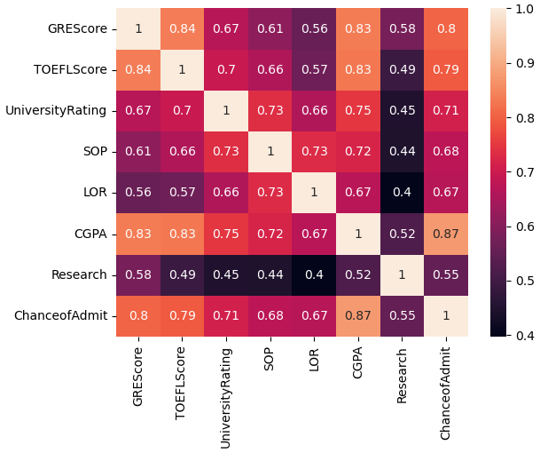

(Figure 1)

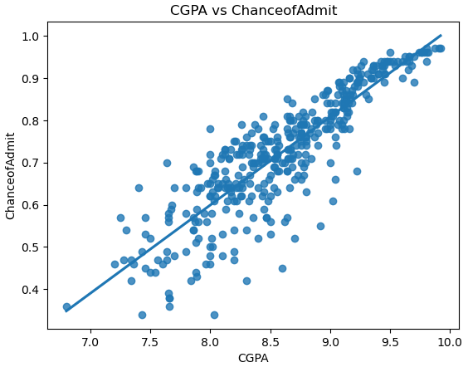

(Figure 2)

### 

(Figure 3)

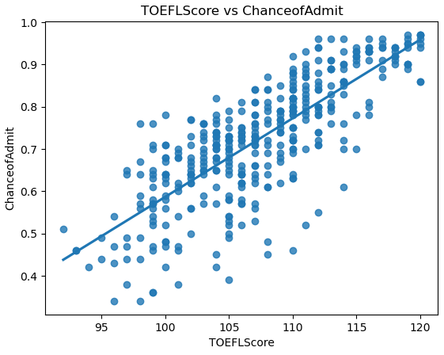

(Figure 4)

### We used a violin plot to check the difference that having research makes of getting admitted to graduation school. From the visualizations we generated we can see that research does make a difference. (Figure 5, 6) We can see by adding Research as a hue to our input variables on the scatter plots that the values increase in chances of getting admitted. (Figure 6)

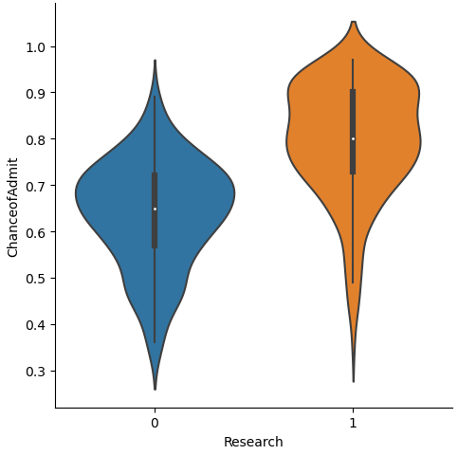

(Figure 5)

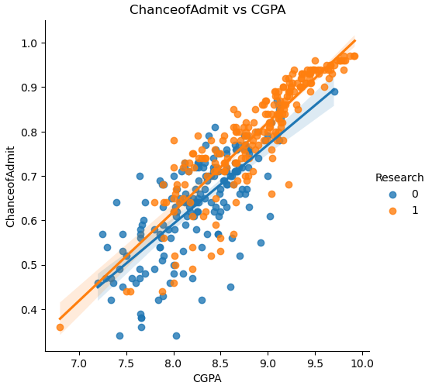

(Figure 6)

### Modeling

For data modeling, we split the data into training and testing(75% and 25% respectively) to train our data model to give accurate predictions. We then fit our Linear regression model to the training data. W can now make predictions.

Evaluating accuracy of Model

Once the data model is trained, we need to check the accuracy of the data model, we seek to get a model that is 99.9% but with the data that we have we only manage to get an accuracy in the range of 70%-75% due to the fact that we are working with a sample size that is not big enough to get a accurate enough prediction.

By getting the coefficient of determination of the prediction and the Mean absolute error regression loss, we can measure the accuracy of the model and then use our features as inputs to get a predicted ChanceofAdmit.

### Recommendations

We can test the accuracy of the model by using your own feature values as inputs for the model, getting a predicted ChanceofAdmission as the output.

The analysis done through the visualizations highlight the factors that a student can work on to increase their chances of admission. Although all features contribute to ChanceofAdmission, these features contribute the most: CGPA, TOEFLScore, GREScore and Research.

# Process of Data analysis

### Data collection

Data collection is the process of gathering and analysing information from various sources to find solutions to research problems. To maintain the integrity and quality of the data, it is essential to collect accurate data. We can make informed business decisions by collecting accurate data. When data is collected, the data types need to be considered aswell as the methods being used and source of the data. [15]

There are two types of data: qualitative and quantitative. Qualitative data is descriptive such as color, size, quality, and appearance. Quantitative data, the data is numeric such as statistics, poll numbers, percentages, etc. These types of data can provide valuable insights. [15]

Primary source of data collection is data that is collected directly by the data researchers. Primary data can be collected using various means such as: surveys, interviews, experiments, and observations. Data that is collected directly by the researcher is more reliable and accurate as the researcher can validate the data. [15]

Secondary source of data collection is data that has already undergone statistical analysis by others and we are now using it in our own research. Secondary data can be collected using various means such as: government databases, industry reports, and academic journals. Secondary data that is collected needs to be handled with care as the data might be inaccurate or irrelevant to the research we are doing. [15]

Data integrity is crucial during the data gathering process. Data integrity helps us to detect any errors in the analysis, whether the errors were done purposefully or not. Quality assurance and quality control are strategies that can be adopted to help protect data integrity and ensure the scientific validity of our results. [15]

Quality assurance involves using procedures to ensure that the data collected is accurate, reliable, and relevant to the research objectives set out. To do this we use standardized data collection instruments, training data collectors, and monitoring of the data collection. Part of the data collection process is also making sure that there are no errors or inconsistencies. [15]

### Data cleaning and preprocessing

Data cleaning is a crucial step in the process of data analysis. Data cleaning involves fixing the errors and inconsistencies found in a dataset so that accurate and reliable results can be collected from it. Incorrect, corrupted, incorrectly formatted, duplicate, or incomplete data can cause for there to be incorrect results, and this can cause for unreliable algorithms to be used. Tt is essential to remove unwanted observations from the dataset, which includes duplicate observations or irrelevant observations. [16]

There is always a likelihood that data could be duplicated or mislabeled, when combining multiple data sources. Duplications and mislabeling can cause there to be inaccurate results in the data, it makes it difficult to identify trends or patterns in the data. To prevent this from happening, we will remove any duplicated or mislabeled data from the dataset. [16]

Structural errors are common issues in data cleaning. The errors can occur when you measure or transfer data and you start to notice strange naming conventions, typos, or incorrect capitalization. The errors can be easily corrected using automated tools or by manual editing them, depending on the complexity of the dataset. [16]

For cleaning data we want to filter out all unwanted outliers in our dataset. The outliers are observations that do not fit within the data that we are analyzing. The observations will skew our results and make it difficult to identify trends or patterns in our data. We have to filter out our unwanted outliers. [16]

If there are any missing values from our data set, there will be problems in our analysis as the machine learning algorithms will not accept missing values, we have to address the missing data in our dataset. We can either drop the data column or insert missing values based on the other observations. We have to be careful when inputting missing values as this can create additional errors in our dataset. [16]

### Exploratory data analysis

Exploratory Data Analysis (EDA) is a data analysis process that involves critically examining data sets to uncover patterns, identify anomalies, test hypotheses, and verify assumptions using the statistics calculated and graphical representations generated. EDA enables data analysts to gain a deep understanding of the data before analysing the complex data. [17]

For EDA, you start with the collection, cleaning, and preparation of the data. The EDA process involves removing irrelevant and missing data and transforming the variables into categorical data. Once the data is prepared, we will generate the summary of statistics, such as: mean, median, and mode. Doing this will allow us to describe the central tendency, variability, and distribution of the data. By summarizing the statistics, it will provide us with an overview of the data set and also enable us to identify potential outliers and anomalies. [17]

In EDA we also like to generate graphical representations in our analysis, such as: histograms, box plots, scatter plots, and heat maps, so that we can visualize the data and detect patterns in the data. Graphical representations help us to identify relationships between the variables and reveal trends and patterns. [17]

EDA is a useful tool for testing hypotheses and verifying assumptions. In data analysis we use statistical tests, such as: t-tests and ANOVA, so that we can determine if there is a significant difference between the groups or if the data meets the assumptions, such as: normality and homogeneity of variance. The results of the tests can help us to conduct further analyses and modelling. [17]

### Visualization tools and techniques

Data visualization is an essential part of most business strategies for companies, the companies want to make sense of the data that they are working with. Data analysts use various methods of data visualization, such as: charts, diagrams, and maps, to present complex data in a simple way. [18]

To make data understandable, we need to use the right techniques and setting it up correctly. It is the only way to unlock the full potential of data. We may as well render the data irrelevant if we use poorly selected tactics as this wont allow us to make sense of the data. [18]

Data visualization is essential in the business's strategy because it allows the organization to gain insight into their data. By using data visualizations, the business can understand their customers' behavior better, they can identify trends, and make data-driven decisions. By having a clear picture of their data, the company can improve the decision-making process, optimize the business's operations, and also stay competitive in the market. [18]

Data visualization helps in communication as data can be complex, so by visualizing the data the information can be conveyed to the stakeholders, especially to those who are not familiar with the data. Data analysts can use the visualizations to present their findings in a visual format that is easy to understand. Doing this, the stakeholders can easily grasp the information and make more informed decisions. [18]

### Data modeling with machine learning

In the field of Artificial Intelligence, Machine Learning automates the decision-making process, especially in the business world. The machine Learning models represents the decision processes in an abstract manner, the primary goal of enabling automation. These models also aid in the understanding of the modelled process itself, so that there is a deeper comprehension of the data being used. [19]

Algorithms are used to train the Machine Learning models; these models then used to analyse data sets. For predictive modelling, there are various tasks depending on the variable being predicted. If the variable is continuous, it falls under the regression task, this will return an actual value. If the variable is divided into categories, it falls under the classification task, the models will then deliver a class. [19]

Regression models use continuous data to predict outcomes, this will allow for trends, patterns, and relationships to be identified between the variables. By analysing the data, a business can make informed decisions based on the forecasted outcomes. The classification models are used when predicting a categorical outcome, such as: classifying emails as spam or not spam. [19]

Machine Learning models are being increasingly used in various industries, including healthcare, finance, and transportation. For example, in healthcare, Machine Learning models can help in predicting disease progression or identifying the most effective treatment options. In the finance industry, models can predict stock prices and identify fraud. In the transportation industry, models can predict traffic and improve route planning. [19]

### Data quality assessment

When building a machine learning model for regression analysis, we need to evaluate its accuracy. There are several metrics that we can use for this purpose, including Mean Squared Error (MSE), Mean Absolute Error (MAE), Root Mean Squared Error (RMSE), and the Coefficient of Determination. [14]

The objective of Linear Regression is to find a line of best fit, that also minimizes the prediction error of all the data points. MSE is a metric used in statistics and data analysis that represents the average of the squared difference between the original and predicted values in the dataset. It measures the variance of the residuals in the dataset, lower the MSE value is, the better the model will perform. [14]

MAE also represents the average of the absolute difference between the actual and predicted values in the dataset. It measures the average of the residuals in the dataset. [14]

RMSE is the square root of MSE and measures the standard deviation of the residuals. RSME is preferred over MSE because it is in the same unit as the dependent variable, this makes it easier to interpret it. [14]

R-Squared represents the proportion of the variance in the dependent variable which can be explained by the linear regression model. It is a scale-free score, this means that it is independent of the values being small or large. The R-Squared value ranges from 0 to 1, a higher value indicates a better performing model. [14]

Adjusted R-Squared is a altered version of R-Squared, it takes into account the number of independent variables there are in the model. As the number of independent variables increases, the Adjusted R-Squared will decrease. [14]

### Data interpretation

Data interpretation is a process that enables data analysts to make sense of the data that was collected. The data researchers use a variety of analytical methods to draw conclusions about the data. Data analysis is often subjective, and the interpretations vary from business and business, this also depends on the type of data being analysed. There are two broad categories of data analysis: quantitative and qualitative analysis. [20][21]

Quantitative analysis is a method of interpreting data, this involves using statistical methods to analyse the numerical data. It is often used to test hypotheses, identify trends, and make predictions. Quantitative analysis allows researchers to quantify data and make objective conclusions based on the analysis. [20][21]

Qualitative analysis is a method of interpreting data, this involves analysing non-numerical data. We seek to understand the social phenomena, explore attitudes and beliefs, and gain insights into issues. Qualitative analysis allows researchers to gain a deeper understanding of the data and draw subjective conclusions based on the analysis. [20][21]

When interpreting the data, the analyst must discern the differences between correlation, causation, and coincidences, as well as other biases – but all the factors need to consider, that may have led to a result. There are various data interpretation methods one could use to achieve this. Having a baseline method for interpretation of the data, will help provide the analyst teams with a structure and consistent foundation. If there are several departments, they may have different approaches to interpreting the same data, there may be a mismatched objective using this approach. Disparate methods will lead to duplicated efforts, inconsistent solutions, wasted energy, wasted time and wasted money. [20][21]